Use Case Description Doc
User Stories Nos. in order of importance: 10, 5, 14, 4, 12, 9, 16, 7, 2, 17, 6, 13, 15, 3, 11, 8, 18, 1
See the UC final diagram(s) link here.

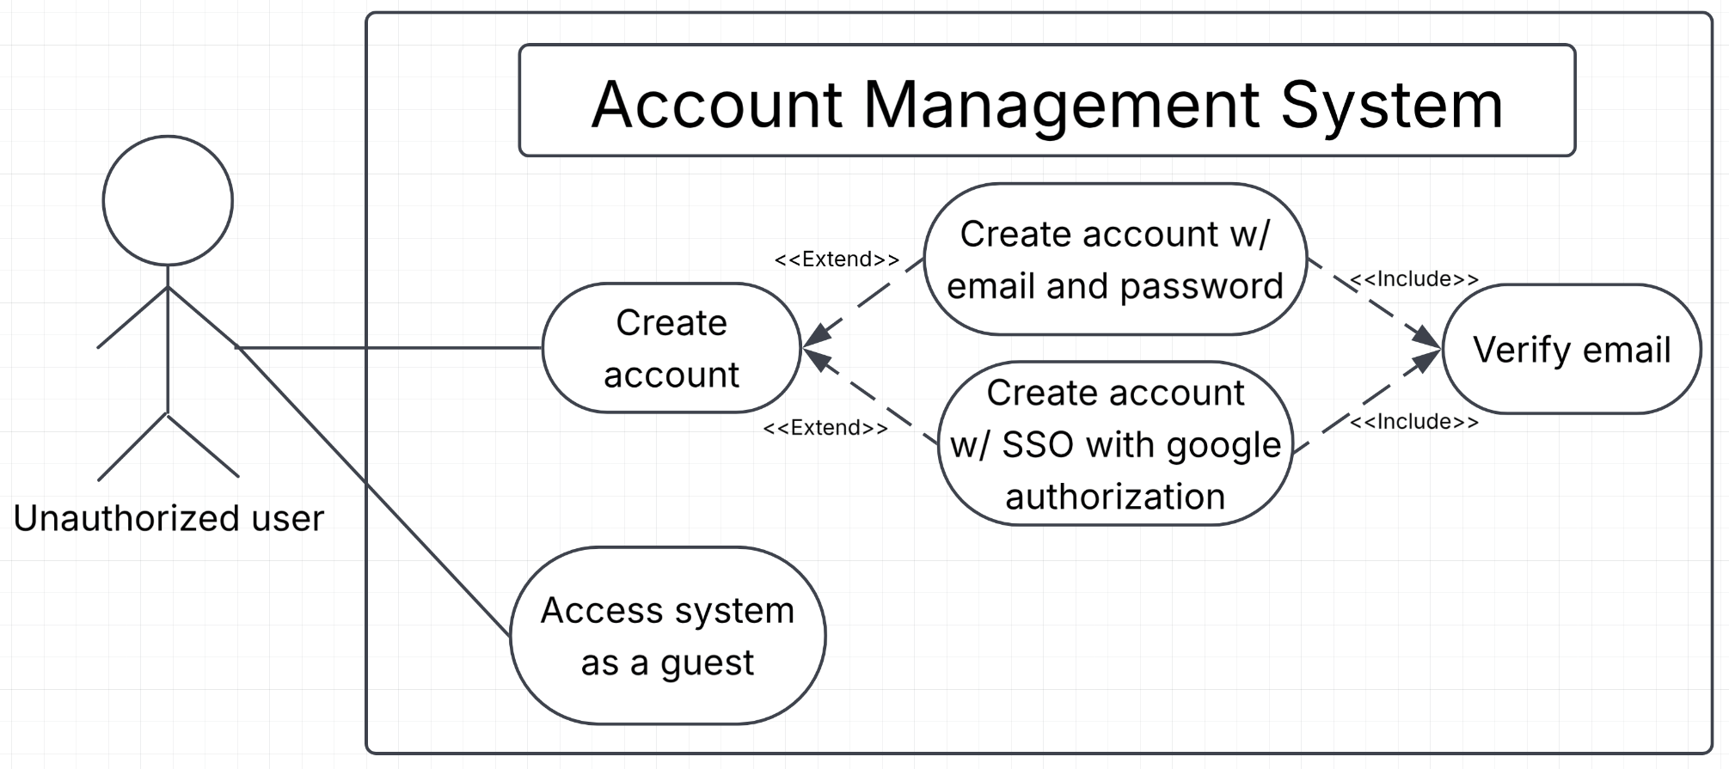

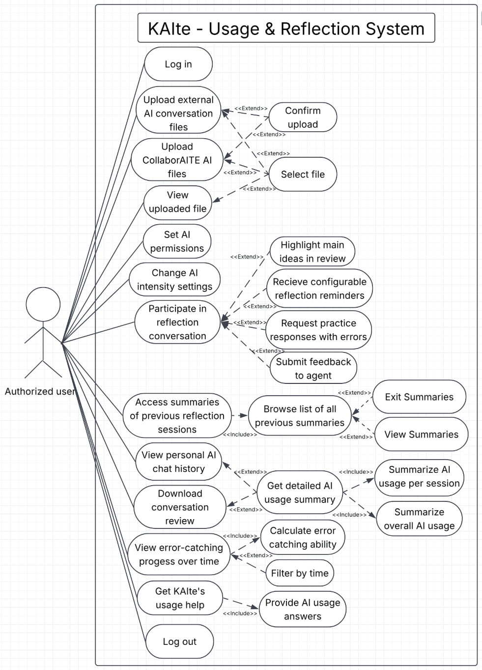

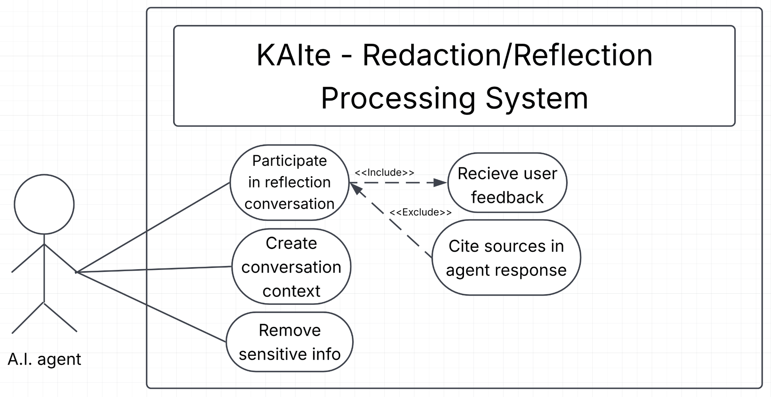

Name/Title: | Create account
ID: | 10
Description: | As an unauthorized user, I want to sign in with an email and password so that I am able to save my chat history, and pick up where I left off.
Related Use Cases: | N/A
Precondition: | Users are logged out, users do not have preexisting accounts, and users provide email and password or their Google account authorization.
Success Postcondition: | The system creates an account for the user with provided username and password allowing them to access the platform.

USER STEPS:  1. The user clicks create new account  2a. The user clicks sign up with email and password  2b. The user clicks sign up with SSO/Google  4. The user inputs corresponding information into the text boxes for their method  4. The user clicks create account  6. The user clicks send email  8. The user verifies their email via the link sent to their email | SYSTEM RESPONSE:  3a. The system opens a pop up to create a new account with an email and password  3b. The system opens a pop up to create a new account with an SSO/Google  5.The system prompts the user to send a verification email to verify their account  7. The system sends email to the user’s given email  9. The system logs the user into their new account if their details are valid

Name: | Upload external AI conversation files
ID: | 05
Description: | As a user, I want to upload conversation logs from the AI models I already use, so that I don’t have to set up and learn a new model to utilize the reflection software.
Related Use Cases: | N/A
Precondition: | The user is logged in, and has external AI conversation logs to upload.
Success Postcondition: | The system stores the conversation log(s).

USER STEPS:  1. The user clicks “Upload Conversation logs”  3. The user selects the conversation file/folder  4. The user confirms their selection | SYSTEM RESPONSE:  2. The system opens file selection dialog  5. The system receives the file/folder  6. The system saves the file to the system  7. The system displays confirmation message  8. The system displays the uploaded file/folder location

Name/Title: | Upload CollaborAITE AI files
ID: | 14
Description: | As an authorized user, I want to upload files and documents from CollaborAITE for the AI to look at during conversations with the user.
Related Use Cases: | N/A
Precondition: | The user is logged in, and has internal AI files (obtained through interacting with agents within CollaborAITE or documents made in CollaborAITE assisted using agents inside the platform) to upload.
Success Postcondition: | The system stores the conversation log(s).

USER STEPS:  1. The user clicks “Import CollaborAITE files”  4. The user selects clicks the file to import  5. The user confirms their selection | SYSTEM RESPONSE:  2. The system retrieves available files from CollboarAITE  3. The system opens file selection dialog showing available files  6. The system receives the file  7. The system displays confirmation message  8. The system displays the uploaded file location

Name/Title: | View error-catching progress over time
ID: | 04
Description: | As an authorized user, I want to view data about my ability to catch AI errors over time so that I can gauge if I’m actually improving.
Related Use Cases: | N/A
Precondition: | The user is logged in, and has access to their error-catching history and progress metrics.
Success Postcondition: | The system displays the user’s error-catching progress metrics over a period of time.

USER STEPS:  1. The user clicks “View error-catching metrics”  4. The user views the error-catching progress metrics details shown  5. The user clicks to “View a [specific] timeframe”  5. The user views the error-catching progress metrics details shown within the chosen timeframe | SYSTEM RESPONSE:  2. The system displays the the error-catching metrics page  3. The system calculates the user’s error-catching abilities over all time  6. The system filters through the user’s error-catching abilities within the chosen timeframe  7. The system calculates the user’s error-catching abilities within the chosen timeframe

Name: | Participate in reflection conversation
ID: | 19
Description: | As a user, I want to have a reflection agent ask me questions about my AI use so that I am prompted to think about and improve how I use AI over time.
Related Use Cases: | N/A
Precondition: | The user is logged in, and has uploaded at least one AI usage log.
Success Postcondition: | The system hosts a reflection conversation that the user can participate in.

USER STEPS:  1. The user clicks “Start reflection conversation”  4. The user responds to the agent’s questions, and asks their own questions if needed  6. The cycle repeats until the user clicks “End conversation” | SYSTEM RESPONSE:  2. The system opens the reflection agent screen  3. The reflection agent initiates a conversation with the user by asking questions about their AI usage from the uploaded log(s)  5. The agent replies to the user, answering the user’s questions where possible and providing follow-up questions for the user to consider  7. The system closes the reflection information screen and saves the data from the conversation

Name/Title: | Get detailed AI usage summary
ID: | 12
Description: | As an authorized user, I want to get a detailed summary of my AI usage of the session and overall after I am done chatting with the AI so that I can see my usage patterns and habits.
Related Use Cases: | N/A
Precondition: | The user is logged in, and has completed a conversation with the agent, and there the user’s AI usage data is stored in the system.
Success Postcondition: | The user is able to view a detailed summary of their AI usage for patterns and habits for the recently completed session and overall all sessions.

USER STEPS:  1. The user clicks “Get detailed AI usage summary” at the end of the conversation with the agent  6. The user reads the collective summary response | SYSTEM RESPONSE:  2. The system generates an AI usage summary of the user based on the recent conversation with the agent  3. The system generates a summary of the user’s AI usage overall, including the last conversation with the agent  4. The system displays the combined summary of the user’s AI usages broken up into sections for the recent conversation and overall

Name/Title: | Get KAIte usage help
ID: | 09
Description: | As a user, I want the agent to answer basic questions about how to use the software’s UI and menus so I can use the software without having to consult external documentation.
Related Use Cases: | N/A
Precondition: | The user is logged in, and is engaging with KAIte’s agent.
Success Postcondition: | The user receives clear answers from the agent on how to use its software’s UI and/or menus.

USER STEPS:  2. The user enters a question about the software’s UI and/or menus  3. The user clicks submit  7. The user views the response  8. The user asks a follow-up question if there are further questions  11. The user views the response | SYSTEM RESPONSE:  1. The system displays a dialog screen  4. The system reviews the question  5. The system generates a response using known information about its system  6. The system displays the response with a prompt for further questions  9. The system reviews the question  10. The system provides further information about its system

Name/Title: | Set AI Permissions
ID: | 16
Description: | As an authorized user, I want to be able to set options for what the AI agent can access from me, so that I can keep sensitive information private.
Related Use Cases: | N/A
Precondition: | The user is logged in, and has access to their AI privacy settings.
Success Postcondition: | The user’s selected AI permissions are saved, and the AI agent only has access to the information the user allowed.

USER STEPS:  1. The user opens the AI privacy settings  3. The user selects what information they want to allow or restrict  5. The user reviews their choices, and edits their selection if needed  6. The user clicks “Saves AI Privacy Settings” | SYSTEM RESPONSE:  2. The system displays the options for what information the AI agent can access  4. The system displays the user’s permission choices  7. The system updates the permission choices based on what the user selected  8. The system saves the permissions

Name/Title: | Submit feedback to agent
ID: | 07
Description: | As an authorized user, I want to give feedback to the reflection agent so that over time it will align more with my needs.
Related Use Cases: | N/A
Precondition: | The user is logged in, and has just concluded a conversation with the reflection agent.
Success Postcondition: | Agent is able to check against user feedback in its memory during continued interaction.

USER STEPS:  2. The user enters their feedback  4. The user clicks to submit their feedback | SYSTEM RESPONSE:  1. The system displays a feedback dialog to prompt the user to submit any feedback  3. The system displays entered feedback  5. The system stores user’s feedback in its memory  6. The system displays confirmation message

Name/Title: | Access Summaries of previous reflection sessions
ID: | 02
Description: | As an authorized user, I want to access summaries of my previous reflection sessions so that I can quickly review them to ensure I’m applying what I discovered in them.
Related Use Cases: | N/A
Precondition: | The user is logged in, has had at least one previous agent conversation, and has access to their conversation history.
Success Postcondition: | The user is able to go through summaries of previous sessions and be able to traverse through them individually.

USER STEPS:  1. Click on the summaries tab  3. Choose a conversation  5. User exits the conversation | SYSTEM RESPONSE:  2. System will display a list all previously saved reflection sessions with the agent  4. System displays a summary of the conversation  6. System no longer displays the conversation dialog and returns to the list of saved chats

Name/Title: | Download conversation review
ID: | 17
Description: | As a learner, I want a quick downloadable review of what the agent and I talked about so that I can look back and not have to read through the entire chat to figure out what the chat was about.
Related Use Cases: | Extensions: #12 - Get detailed AI usage summary
Precondition: | The user has completed a conversation with the reflection agent and a conversation review is available.
Success Postcondition: | The conversation review is successfully downloaded to the user’s device.

USER STEPS:  1. The user opens the conversation review  3. The user selects the option to download the conversation review  5. The user selects where to save the downloaded review | SYSTEM RESPONSE:  2. The system displays the conversation review  4. The system displays dialogue asking where to save the download  6. The system downloads the conversation review to the user’s device

Name/Title: | Remove sensitive info
ID: | 06
Description: | As an authorized user, I want any sensitive personal information automatically removed from the conversations I upload, so that I can partake in the reflection process without worrying about privacy issues.
Related Use Cases: | N/A
Precondition: | The user is logged in and has selected a conversation to upload.
Success Postcondition: | Sensitive personal information is removed from the uploaded conversation before it is used by the reflection agent.

USER STEPS:  1. The user selects what sensitive information to be removed from the uploaded conversation logs  5. The user confirms all selected PII was removed | SYSTEM RESPONSE:  2. The system identifies the sensitive information within the conversation logs  3. The system removes the identified sensitive information within the conversation logs  4. The system displays the conversation with the sensitive personal information removed

Name/Title: | Cite sources in agent response
ID: | 13
Description: | As a learner, I want integrated agent responses with citations to professional documents and curated knowledge based on how to use AI for effective learning and use outside and inside of the chatroom.
Related Use Cases: | N/A
Precondition: | The user is interacting with the reflection agent and submits a question that requires information from a source.
Success Postcondition: | The agent provides a response that includes citations to the source used.

USER STEPS:  3. The user reviews the agent’s response citations | SYSTEM RESPONSE:  1. The system generates a response using relevant professional documents or approved sources  2. The system displays the response with citations to the sources used

Name/Title: | Change AI intensity settings
ID: | 15
Description: | As an authorized user, I want to change settings for the AI’s intensity so that I can configure the AI to be more involved in conversations or leave it more open-ended.
Related Use Cases: | N/A
Precondition: | The user is logged in and has access to the AI settings.
Success Postcondition: | The user’s selected AI intensity setting is saved and applied to future interactions with the reflection agent.

USER STEPS:  1. The user opens the AI settings  3. The user selects their preferred AI intensity level  5. The user confirms the selected intensity setting | SYSTEM RESPONSE:  2. The system displays the available AI intensity settings  4. The system updates the selected AI intensity level  6. The system saves the settings

Name/Title: | Request practice responses with errors
ID: | 03
Description: | As a user, I want to make the reflection agent give practice responses with intentional errors, so that I can practice catching them.
Related Use Cases: | N/A
Precondition: | The user is interacting with the reflection agent and has access to the practice response feature.
Success Postcondition: | The reflection agent provides the user with a practice response containing intentional errors.

USER STEPS:  1. The user selects the option to receive a practice response with intentional errors  3. The user submits a prompt or topic for the practice response  6. The user reviews the practice response and attempts to identify the errors | SYSTEM RESPONSE:  2. The system enables the intentional error practice feature  4. The system generates a practice response containing intentional errors  5. The system displays the practice response to the user

Name/Title: | View personal AI chat history
ID: | 11
Description: | As an authorized user, I want to view my personal AI chat history on my account so that I am able to look back on previous chats I have had with the reflection agent.
Related Use Cases: | Extensions: #12 - Get detailed AI usage summary
Precondition: | The user is logged in and has previous saved conversations with the reflection agent.
Success Postcondition: | The user is able to view a selected previous conversation from their saved AI chat history.

USER STEPS:  1. The user opens their AI chat history  3. The user selects a previous conversation  5. The user reviews the selected conversation | SYSTEM RESPONSE:  2. The system displays the user’s saved AI chat history  4. The system opens and displays the selected conversation  6.The system continues displaying the conversation until the user exits or selects another conversation

Name/Title: | Receive configurable reflection reminders
ID: | 08
Description: | As an authorized user, I want to receive configurable reminders to do reflection, so that I consistently go through the process and don’t forget about it because of other work.
Related Use Cases: | N/A
Precondition: | The user is logged in and has access to the reflection reminder settings.
Success Postcondition: | The user’s selected reflection reminder settings are saved and reminders are sent according to those settings.

USER STEPS:  1. The user opens the reflection reminder settings  3. The user selects when they want to receive reflection reminders  5. The user saves the reminder settings | SYSTEM RESPONSE:  2. The system displays the available reflection reminder settings  4. The system updates the reminder schedule based on the user’s selections  6. The system saves the reminder settings and confirms the changes  7. The system sends out a reminder at the scheduled times

Name/Title: | Highlight main ideas in review
ID: | 18
Description: | As a learner, I want to be able to highlight main ideas of the conversation with the agent in a review so that I can quickly know what a conversation was about based on the main points.
Related Use Cases: | N/A
Precondition: | The user has completed a conversation with the reflection agent and a conversation review is available.
Success Postcondition: | The main ideas from the conversation are highlighted and displayed in the conversation review.

USER STEPS:  1. The user opens a conversation review  3. The user selects the option to highlight the main ideas  6. The user reviews the highlighted main ideas | SYSTEM RESPONSE:  2. The system displays the conversation review  4. The system identifies and highlights the main ideas from the conversation  5. The system displays the review with the main ideas highlighted

Name/Title: | Access system as guest
ID: | 01
Description: | As an unauthorized user, I want to access the system as a guest so I can get a quick analysis of my AI usage without worrying about data retention.
Related Use Cases: | N/A
Precondition: | The user is not logged into an account and is on the system’s main page.
Success Postcondition: | The user is granted guest access to the system without creating an account, and the user’s session data is not retained after the guest session ends.

USER STEPS:  1. The user selects the option to continue as an unauthorized user  3. The user begins an unauthorized user session  5. The user ends the unauthorized user session when finished | SYSTEM RESPONSE:  2. The system grants the user guest access without requiring an account  4. The system allows the user to access the available guest features and receive an analysis of their AI usage  6. The system ends the guest session without retaining the user’s session data

